1. Read multiple JSON files into a directory to convert into a dataset.

I have files text1, text2, text3 in the directory JSON.

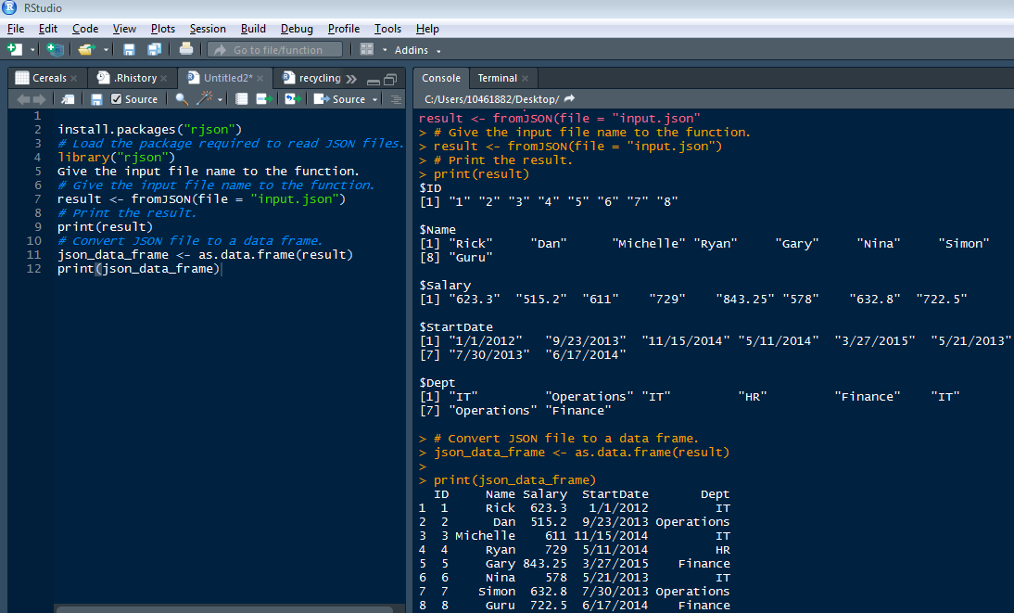

2. Parse the following JSON into a data frame.

js<-'{

"name": null, "release_date_local": null, "title": "3 (2011)",

"opening_weekend_take": 1234, "year": 2011,

"release_date_wide": "2011-09-16", "gross": 59954

}'

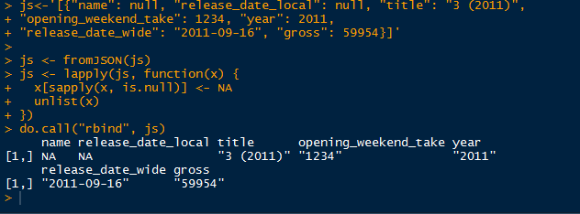

3. Write a script for Variable Binning using R.

